

**SANGGUNIANG KABATAAN PEDERASYON**

Province of Laguna

MUNICIPALITY OF LUISIANA

*Contact Number: 555 – 3411* | *+63 915 36 13226*

**20 February 2019**

**RAMON B. VALDENARRO**

State Auditor IV

*Commission on Audit*

**Dear Sir Valdenarro,**

This pertains to the disbursement and utilization of SK funds. Pursuant to Section 21 of the Implementing Rules and Regulations of Republic Act No. 10742, otherwise known as the Sangguniang Kabataan Reform Act of 2015, “the COA shall formulate accounting and auditing guidelines pertaining to the proper recording, reporting and audit of SK funds and such other funds, including but not limited to, funds of Pederasyon in all levels.”

In this regard, and to ensure that the SKs of the Municipality of Luisiana shall adhere to the guidelines on the proper use of SK funds before being subject to accounting and auditing, we would like respectfully inquire as to **how the SK fund may be disbursed for the upcoming SK activities, programs, projects and activities under the Annual Barangay Youth Investment Program given that COA has yet to release the guidelines.**

We hope to receive your response on this matter, the soonest possible time.

Thank you very much.

In the Service of the Filipino Youth,

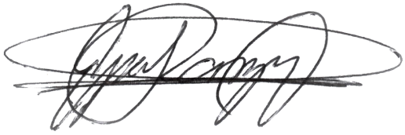

**HON. NEIL GABRIEL ESPERANZA**

*SK Pederasyon President*